1.

a. Create a web page having the background in green and title “My First Page”.

<html>

<head><title>my first page</title></head>

<style>

body{background-color:green;

}</style>

<body></body>

</html>



b. Create a web page of pink colour and display a moving message in red colour.

<html>

<head><title>1b</title></head>

<style>

marquee{

font-size:30px;

color:red;

}

</style>

<body style="background-color:pink;">

<h1 style="font-size:60px;color:blue;">Here you can see the text is moving</h1>

<marquee>

hello! every one Welcome to web technology lab.here you can learn

html,xml,java script.best website to learn all this is w3 schools.</marquee>

</body>

</html>

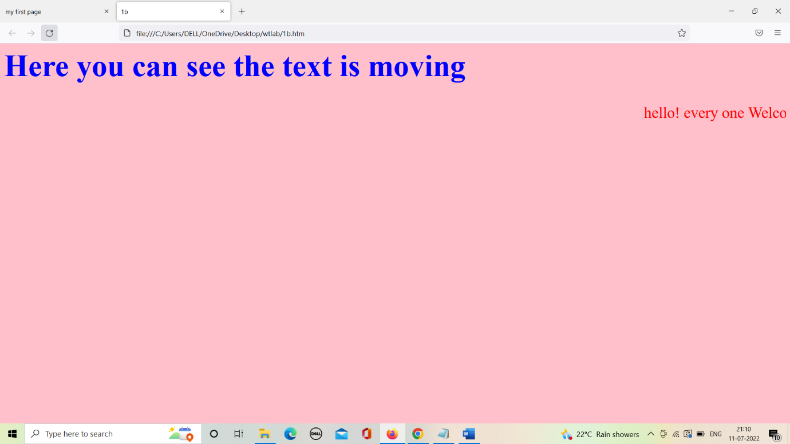

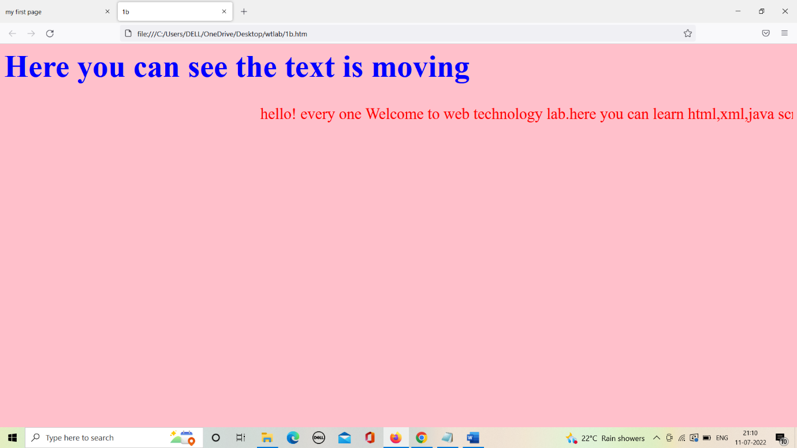

c. Design a web page containing text, in form of paragraphs giving suitable heading style

<html>

<head><title>1c</title></head>

<style>

h1,h2,h3,h4,h5,h6{

color:blue;

}

p{

color:red;

}

</style>

<body>

<p style="font-size:40px;color:green;">paragraph and heading style</p>

<h1>keerthi</h1>

<p>keerthi is a good girl</p>

<h2>pujitha</h2>

<p>pujitha is good friend for keerthi</p>

<h3>ajitha</h3>

<p>aji,puji,keer are good frnds</p>

<h4>pres</h4>

<p>keerthi's new frnd -pres</p>

<h5>vandana</h5>

<p>vandana is keerthi's childhood frnd</p>

<h6>nan</h6>

<p>nan,van,keer are good frnds</p>

</body>

</html>

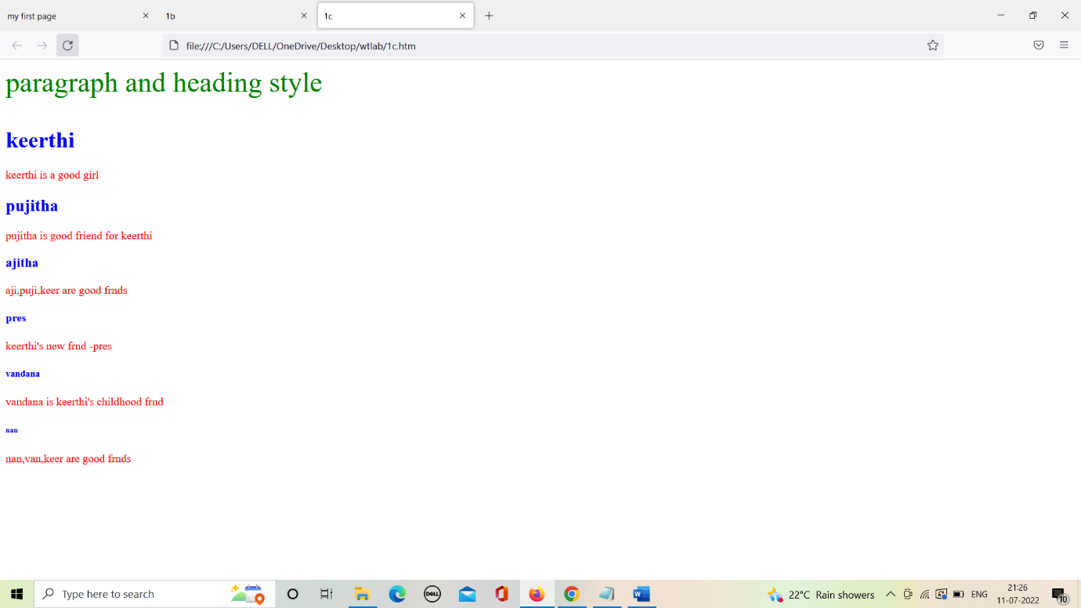

2.

a. Create a web page which displays WELCOME text using heading tags(h1 to h6)

<html>

<head><title>2a</title></head>

<body>

<style>

h1,h2,h3,h4,h5,h6{

text-align:center;

}

</style>

<body>

<h1>WELCOME</h1>

<h2>WELCOME</h2>

<h3>WELCOME</h3>

<h4>WELCOME</h4>

<h5>WELCOME</h5>

<h6>WELCOME</h6>

</body>

</html>

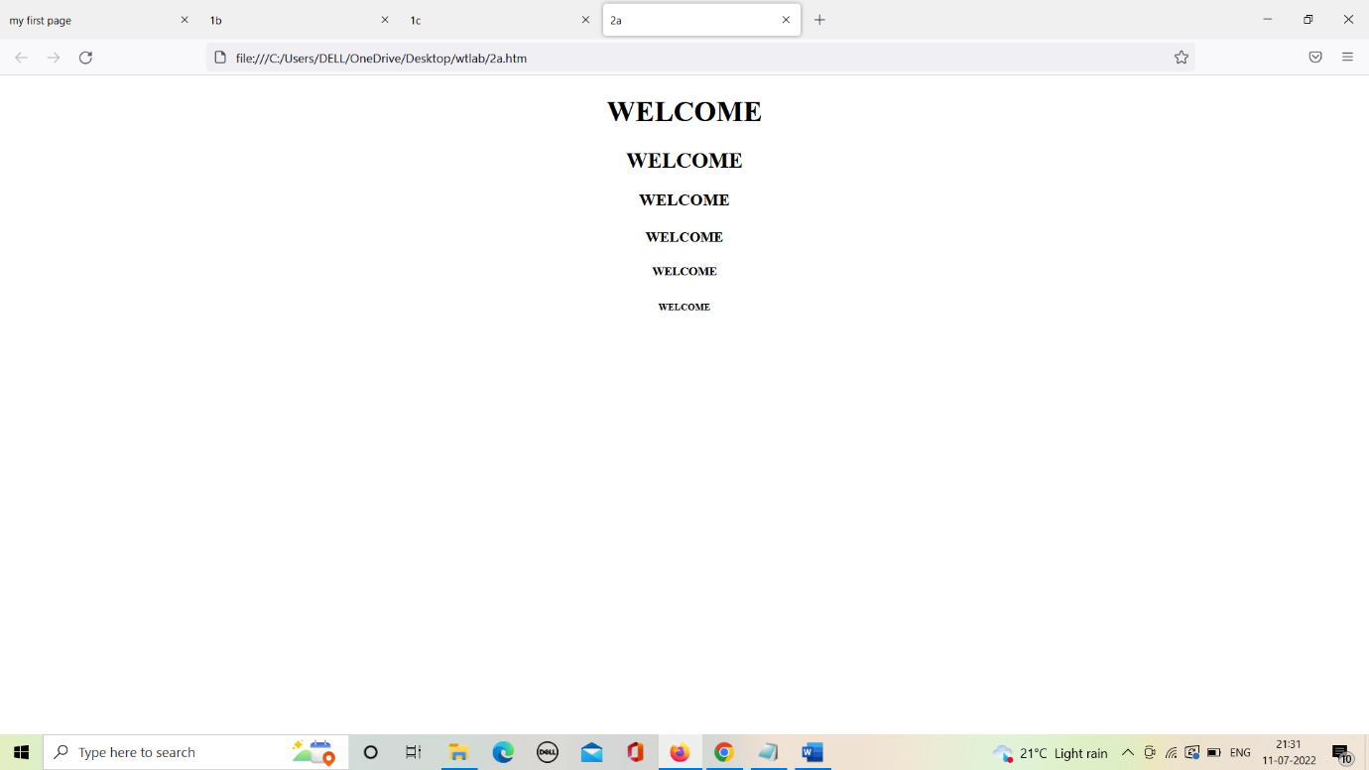

b. Create a web page which displays WELCOME text using <b> tag

<html>

<head><title>2b</title></head>

<body>

<h1 style="text-align:center;"><b>WELCOME</b></h1>

</body>

</html>

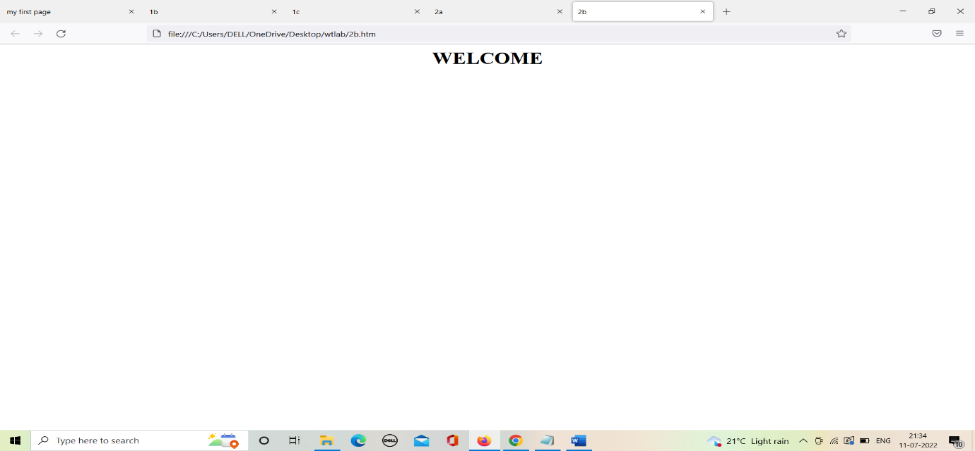

c. Create a web page which displays h2o and x2+y2 using <sup> tag and <sub> tag

<html>

<head><title>2c</title></head>

<style>

p{

text-align:center;

font-size:30px;

color:pink;

}

</style>

<body>

<p style="color:blue;">Below represent sub and sup tags</p>

<p>h<sub>2</sub>0 - means water</p>

<p>x<sup>2</sup>+y<sup>2</sup>=0 represent circle vth radius "0"</p>

</body>

</html>

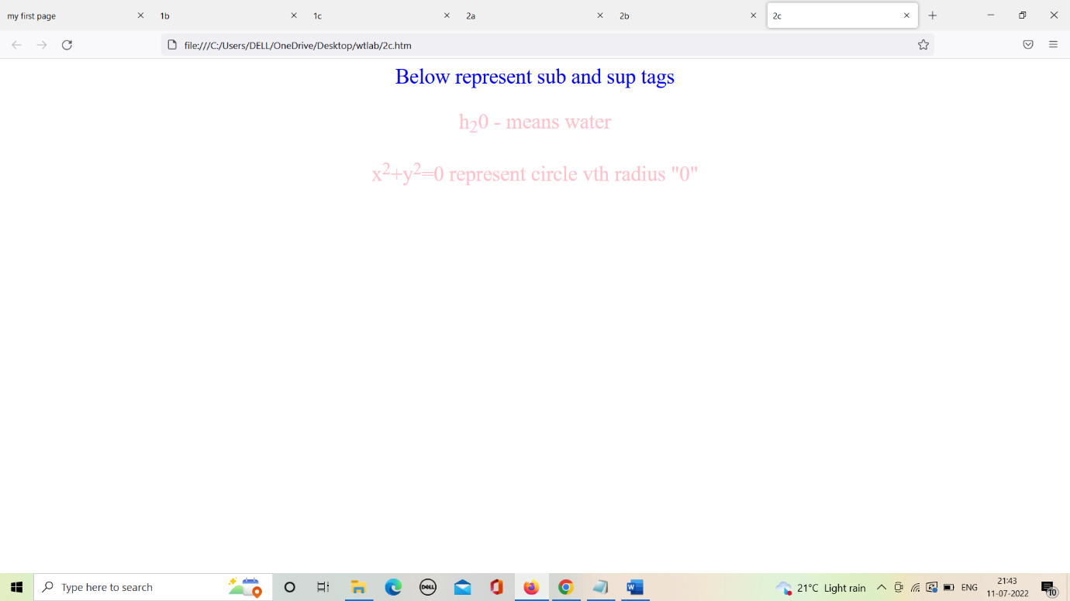

3.

a. Create a web page to show different attributes of Font tag.

<html>

<head><title>3a</title></head>

<center>

<body style="color:blue;">

<p style="font-size:40px;">Font Attributes</p>

<p style="font-size:30px;color:green;">font-size</p>

<font size="1">Hello HTML 5!</font><br>

<font size="2">Hello HTML 5!</font><br>

<font size="3">Hello HTML 5!</font><br>

<font size="4">Hello HTML 5!</font><br>

<font size="5">Hello HTML 5!</font><br>

<font size="6">Hello HTML 5!</font><br>

<p style="font-size:30px;color:green;">font-face</p>

<font face="Times New Roman" size="5">Times New Roman</font><br>

<font face="Verdana" size="5">Verdana</font><br>

<font face="Comic sans MS" size="5">Comic Sans MS</font><br>

<p style="font-size:30px;color:green;">font-color</p>

<font color="red" size="4">red</font><br>

<font color="blue" size="4">blue</font><br>

<font color="violet" size="4">violet</font><br>

</body>

</center>

</html>

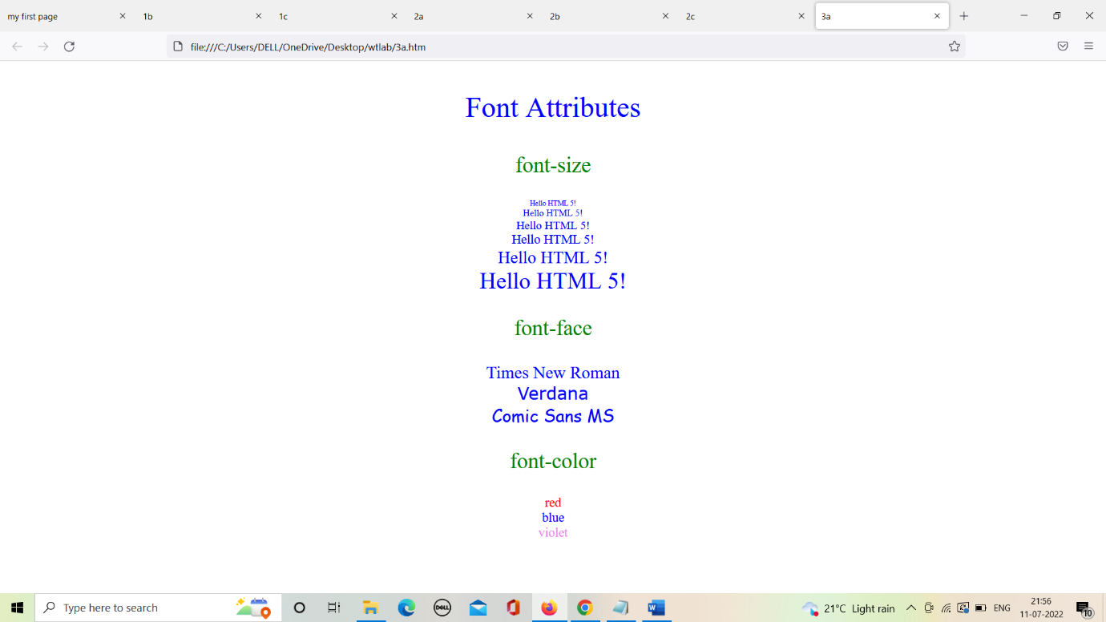

b. Create a web page to show different attributes: italics, bold, underline.

<html>

<head><title>3b</title></head>

<style>

p{

font-size:40px;

color:blue;

}

</style>

<center>

<body>

<h1>Different texts</h1>

<p><b>text is in bold</b></p>

<p><i>text is in bold</i></p>

<p><u>text is in bold</u></p>

</body>

</center>

</html>

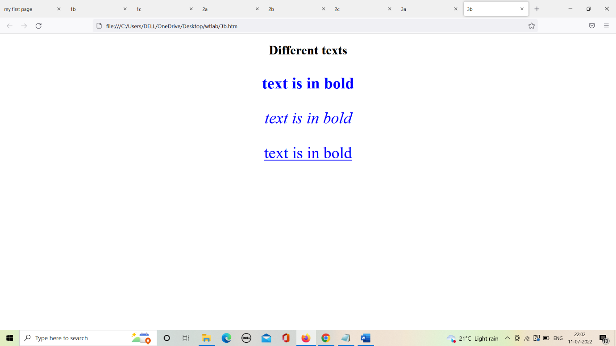

c. Design a web page having background colour yellow and giving text colour red

<html>

<head><title>3c</title></head>

<style>

pre{

font-size:30px;

color:red;

}

body{

background-color:yellow;

}

</style>

<body>

<pre>“Be yourself; everyone else is already taken.”

― Oscar Wilde

“You've gotta dance like there's nobody watching,

Love like you'll never be hurt,

Sing like there's nobody listening,

And live like it's heaven on earth.”

― William W. Purkey

“Be the change that you wish to see in the world.”

― Mahatma Gandhi

“There are only two ways to live your life.

One is as though nothing is a miracle. The other is as though everything is a miracle.”

― Albert Einstein

</pre>

</body>

</html>

